**Neha Malhotra**  **R.L. Institute M: 9416974837**

**Subject: Biology**

**Topic: Animal kingdom upto Non-Chordates**

**M.M. 360 COMPETITIVE TEST**  **Time: 90 Min.**

1. Members of phylum porifera commonly called as :

|  |  |  |  |
| --- | --- | --- | --- |
| a) Flat worm | b) Round worm | c) Sponges | d) Shelled animals |

1. Majority of poriferans are inhabitant of :

|  |  |  |  |
| --- | --- | --- | --- |
| a) Fresh water | b) Brackish water | c) Marine water | d) None of above |

1. Sponges have canal system for circulation of :

|  |  |  |  |
| --- | --- | --- | --- |
| a) Blood | b) Cytoplasm | c) Water | d) Lymph |

1. Inlet and outlet for the water in the canal system is respectively :

|  |  |
| --- | --- |
| a) Ostia and spongocoel | b) Ostia and Coelom |
| c) Ostia and Osculum | d) Ostia and Pseudocoelom |

1. Development in members porifera is :

|  |  |
| --- | --- |
| a) Direct without larval stage | b) Indirect with larval stage |
| c) Direct with larval stage | d) Indirect without larval stage |

1. Sycon is commonly called as :

|  |  |  |  |
| --- | --- | --- | --- |
| a) Fresh water sponge | b) Bath sponge | c) Scypha | d) Boring sponge |

1. Which sponge is commonly called as “bath sponge”

|  |  |  |  |
| --- | --- | --- | --- |
| a) Sycon | b) Euplectella | c) Spongilla | d) Euspongia |

1. Which of the following is incorrect statement regarding cnidaria :

|  |  |
| --- | --- |
| a) They are aquatic but majority are marine | b) They can be sessile or free swimming |
| c) They have radial symmetry | d) They have tube with in tube body plan |

1. The name cnidaria is derived from which of the following cell :

|  |  |  |  |
| --- | --- | --- | --- |
| a) Interstitial cell | b) Collar cell | c) Archaeocyte | d) Cnidoblast |

1. Cnidarians are

|  |  |
| --- | --- |
| a) Diploblastic | b) Having tissue level of organization |
| c) Bilateral symmetry | d) Both (a) & (b) |

1. Hypostome is opening of :

|  |  |  |  |
| --- | --- | --- | --- |
| a) Cnidoblast | b) Cnidocytes | c) Coelenteron | d) Spongocoel |

1. Polyp of *hydra* and *adamsia* is :

|  |  |  |  |
| --- | --- | --- | --- |
| a) Sessile | b) Cylindrical | c) Umbrella shaped | d) Both (a) & (b) |

1. Medusa of *Aurelia*, commonly referred as jelly fish is :

|  |  |
| --- | --- |
| a) Free swimming in aquatic habitat | b) Tree or cylindrical shaped |
| c) Umbrella shaped | d) Both (a) & (c) |

1. Which of the following statement is correct
2. Ctenophores are triploblastic.
3. Ctenophores have tissue level of organization.
4. Ctenophores are exclusively marine in habitat.
5. Ctenophores shows bilateral symmetry.

|  |  |  |  |
| --- | --- | --- | --- |
| a) (i) & (ii) | b) (ii) & (iii) | c) (iii) & (iv) | d) (iv) & (i) |

1. Ctenophores are commonly called as

|  |  |  |  |
| --- | --- | --- | --- |
| a) Sea walnuts | b) Comb jellies | c) Sea dollar | d) Both (a) & (b) |

1. Body of ctenophores is having how many rows of comb plates :

|  |  |  |  |
| --- | --- | --- | --- |
| a) 2 | b) 4 | c) 6 | d) 8 |

1. Which of the following are members of Ctenophora

|  |  |  |  |
| --- | --- | --- | --- |
| a) Pleurobrachia | b) Ctenoplana | c) Gorgonia | d) Both (a) & (b) |

1. Which of the following statement are incorrect
2. Cnidocytes are present on tentacles.
3. Diploblastic with cellular level of organization.
4. Polyp forms are free swimming.
5. Exhibit metagenesis.

|  |  |  |  |
| --- | --- | --- | --- |
| a) (i) & (ii) | b) (ii) & (iii) | c) (iii) & (iv) | d) (iv) & (i) |

1. Cellular grade of body is present in :

|  |  |  |  |
| --- | --- | --- | --- |
| a) Annelida | b) Platyhelminthes | c) Porifera | d) Urochordata |

1. Find out the odd one :

|  |  |  |  |
| --- | --- | --- | --- |
| a) Adamsia | b) Pennatula | c) Physalia | d) Pleurobrachia |

1. Which is incorrect statement in case of flat worms.

|  |  |
| --- | --- |
| a) They are triploblastic | b) They are Acoelomate |
| c) They are mostly endoparasite | d) They are showing bioluminescence |

1. The body of Aschelminthes is :

|  |  |  |  |
| --- | --- | --- | --- |
| a) Horizontal | b) Longitudinal | c) Circular | d) Vertical |

1. Which of the following is not correct regarding the round worm :

|  |  |
| --- | --- |
| a) They are parasite in plants and animals | b) They have organ level of organization |
| c) They are bilateral symmetrical | d) They are true coelomates |

1. Regarding the male and female round worm which of the following is correct :

|  |  |
| --- | --- |
| a) Male is longer than female | b) Male and female are of same length |
| c) Female is shorter than Male | d) Female is longer than Male |

1. Nereis possesses lateral appendages which help in swimming are :

|  |  |  |  |
| --- | --- | --- | --- |
| a) Setae | b) Suckers | c) Parapodia | d) Hooks |

1. Nephridia in phylum Annelida helps in :

|  |  |  |  |
| --- | --- | --- | --- |
| a) Osmoregulation | b) Excretion | c) Respiration | d) Both (a) & (b) |

1. over 2/3rd of all named and identify species on the earth belong to :

|  |  |  |  |
| --- | --- | --- | --- |
| a) Arthropoda | b) Annelida | c) Mollusca | d) Mammalia |

1. Exoskeleton of members of phylum Arthropoda is composed of :

|  |  |  |  |
| --- | --- | --- | --- |
| a) Cellulose | b) Chitin | c) lipid | d) Protein |

1. Spider and scorpion respire with the help of :

|  |  |  |  |
| --- | --- | --- | --- |
| a) Book gills | b) Book lungs | c) Gills | d) Respiratory siphon |

1. Statocyst in members of Arthropoda is meant for :

|  |  |  |  |
| --- | --- | --- | --- |
| a) Balancing | b) Hearing | c) Touch | d) Vision |

1. Malpighian tubules are meant for which physiological activity :

|  |  |  |  |
| --- | --- | --- | --- |
| a) Digestion | b) Excretion | c) Respiration | d) Reproduction |

1. Which of the following is economically insect :

|  |  |  |  |
| --- | --- | --- | --- |
| a) *Anopheles* | b) *Culex* | c) *Bombyx* | d) *Limulus* |

1. Which of the following is powerful vector (in mosquito) of diseases?

|  |  |  |  |
| --- | --- | --- | --- |
| a) *Crab* | b) Palaemon | c) Julus | d) *Aedes* |

1. Which of the following statements are correct regarding to phylum coelenterate?
2. They are aquatic, mostly marine, sessile or free swimming, radial symmetrical animals.
3. They have a central gastro vascular cavity with a single opening called Hypostome.
4. Digestion is extracellular and intracellular.
5. Examples are : *Sycon , Spongilla , Euspongia*

|  |  |  |  |
| --- | --- | --- | --- |
| a) (i) & (ii) | b) (i) & (iv) | c) (i) , (ii) & (iii) | d) All of these |

1. Limulus, also called King crab is living fossil, respire with the help of :

|  |  |  |  |
| --- | --- | --- | --- |
| a) Book lungs | b) Book gills | c) Tracheal gills | d) Ctenidea |

1. Which one is example of living fossil :

|  |  |  |  |
| --- | --- | --- | --- |
| a) Coral | b) Ascidia | c) Octopus | d) King crab |

1. Which of the following is incorrect statement?

|  |  |
| --- | --- |
| a) Mollusca have organ system level of organization | b) Mollusca have bilateral symmetry |
| c) Body of Mollusca is segmented | d) Mollusca are true coelomate |

1. Body of Mollusca is divided into :

|  |  |  |  |
| --- | --- | --- | --- |
| a) Head | b) Muscular foot | c) Visceral hump | d) All of above |

1. A file like rasping organ for feeding is present in Mollusca, name as :

|  |  |  |  |
| --- | --- | --- | --- |
| a) Ctenidia | b) Radula | c) Ospharidium | d) Cuversian tubules |

1. *Aplysia* commonly called as :

|  |  |  |  |
| --- | --- | --- | --- |
| a) Tusk shell | b) Sea dollar | c) Sea hare | d) Sea mouse |

1. *Tusk shell* commonly called as :

|  |  |  |  |
| --- | --- | --- | --- |
| a) Chaetoplura | b) Loligo | c) Pinctada | d) Dentalium |

1. *Chiton* commonly called as :

|  |  |  |  |
| --- | --- | --- | --- |
| a) Neopilina | b) Chaetopleura | c) Mytilus | d) Unio |

1. Role played by water vascular system is :

|  |  |  |  |
| --- | --- | --- | --- |
| a) Locomotion | b) Capture of food | c) Transport of food | d) All of these |

1. Which type of symmetry is recorded in phylum Hemichordata :

|  |  |  |  |
| --- | --- | --- | --- |
| a) Radial | b) Spherical | c) Bilateral | d) Biradial |

1. Germ layer in Hemichordata is :

|  |  |  |  |
| --- | --- | --- | --- |
| a) Ablastic | b) Monoblastic | c) Diploblastic | d) Triploblastic |

1. Which one of the following is a Mollusca

|  |  |  |  |
| --- | --- | --- | --- |
| a) *Physalia* | b) *Fasiola* | c) *Octopus* | d) *Spongilla* |

1. Select correct statement form following :

|  |  |
| --- | --- |
| a) All arthropods have one pair of tentacles | b) All arthropods have an external & internal shell |
| c) All annelida have setae for locomotion | d) All echinoderms have water vascular system |

1. Pearl is characteristic feature of

|  |  |  |  |
| --- | --- | --- | --- |
| a) Mollusca | b) Porifera | c) Echinoderms | d) Hemichordata |

1. In most simple type of canal system of Porifera, water flows through which of following ways?

|  |  |
| --- | --- |
| a) Ostia $→$ Spongocoel $→$ Osculum $→$ Exterior | b) Spongocoel $→$ Ostia $→$ Osculum $→$ Exterior |
| c) Osculum $→$ Spongocoel $→$ Ostia $→$ Exterior | d) Osculum $→$ Ostia $→$ Spongocoel $→$ Exterior |

1. Metagenesis is seen in :

|  |  |  |  |
| --- | --- | --- | --- |
| a) Hydra | b) Aurelia | c) Obelia | d) Adamsia |

1. Animal of which have hook & suckers and are endoparasite on other animals?

|  |  |  |  |
| --- | --- | --- | --- |
| a) Platyhelminthes | b) Annelida | c) Aschelminthes | d) Arthropoda |

1. The adult are radial symmetry but larval exhibit bilateral symmetry

|  |  |  |  |
| --- | --- | --- | --- |
| a) Mollusca | b) Hemichordata | c) Echinodermata | d) Cephalocordata |

1. Cellular grade of organization is found in :

|  |  |  |  |
| --- | --- | --- | --- |
| a) Helminthes | b) Coelenterate | c) Porifera | d) All of these |

1. Which one of sponge part corresponds to mouth of other animals :

|  |  |  |  |
| --- | --- | --- | --- |
| a) Osculum | b) Ostia | c) Incurrent canal | d) Excurrent canal |

1. Planaria, Liver fluke and Taenia are :

|  |  |  |  |
| --- | --- | --- | --- |
| a) All segmented | b) All found in the gut | c) All have coelom | d) All are flat |

1. Portuguese man of war is :

|  |  |  |  |
| --- | --- | --- | --- |
| a) Sea pen | b) Coral | c) Physalia | d) Obelia |

1. Bioluminescence is well marked in :

|  |  |  |  |
| --- | --- | --- | --- |
| a) Flat worm | b) Ctenophora | c) Porifera | d) Aschelminthes |

1. Which of the following options shows the correct name of the animals shown by given figures:

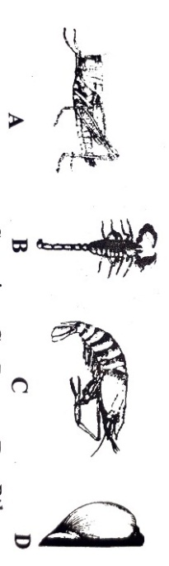

|  |  |
| --- | --- |
| a) **A** = Locust , **B** = Scorpion , **C** = Prawn , **D** = Pila | b) **A** = Locust , **B** = Prawn , **C** = Scorpion , **D** = Pila |
| c) **A** = Locust , **B** = Scorpion , **C** = Prawn , **D** = Snail | d) **A** = Butterfly , **B** = Prawn , **C** = Scorpion , **D** = Pila |

|  |
| --- |
|  |

1. Read the given figure and identify correct option :

|  |  |  |  |  |
| --- | --- | --- | --- | --- |
|  | A | B | C | D |
| (a) | Pleurobrachia | Cnidoblast | Aurelia | Adamsia |
| (b) | Aurelia | Adamsia | Cnidoblast | Pleurobrachia |
| (c) | Cnidoblast | Pleurobrachia | Adamsia | Aurelia |
| (d) | Adamsia | Aurelia | Pleurobrachia | Cnidoblast |

1. Read the given figure and identify correct option :

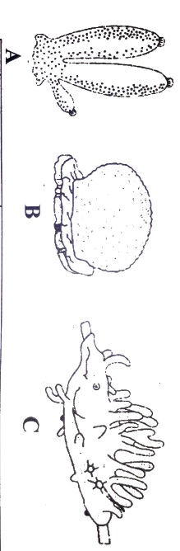

|  |  |
| --- | --- |
| a) **A** = Sycon , **B** = Euspongia , **C** = Spongilla | b) **A** = Euspongia , **B** = Spongilla , **C** = Sycon |
| c) **A** = Spongilla , **B** = Sycon , **C** = Euspongia | d) **A** = Euspongia , **B** = Sycon , **C** = Spongilla |

1. Identify the figure and select correct order :

|  |
| --- |
|  |

|  |
| --- |
|  |

a) **A** = Pseudocoelomate , **B** = Coelomate , **C** = Acoelomate

b) **A** = Coelomate , **B** = Pseudocoelomate , **C** = Acoelomate

c) **A** = Coelomate , **B** = Acoelomate , **C** = Pseudocoelomate

d) **A** = Coelomate , **B** = Acoelomate , **C** = Eucoelomate

1. Identify figure with its correct name

|  |  |
| --- | --- |
| a) Sycon | b) Ctenoplana |
| c) Aurelia | d) Tapeworm |

1. Identify figure with its correct name and phylum :

Proboscis Collar Trunk

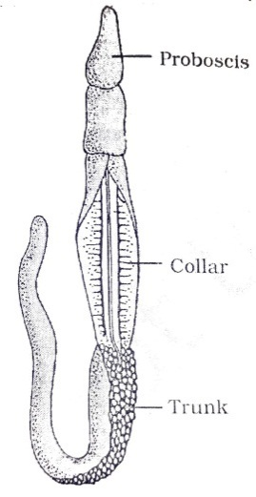

|  |  |
| --- | --- |
| a) Cucumaria - Echinodermata | b) Ascidia – Urochordata |
| c) Balanoglossus - Hemichordata | d) Hirudinaria - Annelida |

1. Which of the following statement is incorrect about porifera :

|  |  |
| --- | --- |
| a) They all have calcareous spicules | b) They have regeneration power |
| c) They are found mostly in marine water | d) They all are radially symmetrical |

1. Match column I and column II

|  |  |
| --- | --- |
| Column I | Column II |
| A. Pseudocoelomate | I. Hydra , Adamsia |
| B. Polyp form | II. Ctenoplana , Aurelia |
| C. Organ level of organization | III. Ascarias , Wuchereria |
| D. Radial symmetry  E. Metamerism segmented | IV. Sycon , Spongilla  V. Pheretima , Nereis |

|  |  |
| --- | --- |
| a) A – V ; B – II ; C – IV ; D – III ; E – I | b) A – III ; B – I ; C – IV ; D – II ; E – V |
| c) A – II ; B – I ; C – III ; D – V ; E – IV | d) A – III ; B – II ; C – IV ; D – I ; E – V |

1. Match column I and column II

|  |  |
| --- | --- |
| Column I | Column II |
| A. Pennatula | I. Sea – lily |
| B. Antendon | II. Sea – Pen |
| C. Echinus | III. Sea – urchin |
| D. Cucumaria | IV. Sea – cucumber |

|  |  |
| --- | --- |
| a) A – II ; B – III ; C – I ; D – IV | b) A – II ; B – IV ; C – I ; D – III |
| c) A – II ; B – I ; C – III ; D – IV | d) A – III ; B – I ; C – IV ; D – III |

1. Read following statement and answer the following question. : “Name of **‘X ‘**is derived from stinging capsules. It exhibits metagenesis containing two body forms in which sessile and cylindrical form is called **‘Y’** and umbrella shaped is called **‘Z’**. Identify X , Y and Z

|  |  |
| --- | --- |
| a) **X** = Coelenterate , **Y** = Polyp , **Z** = Medusa | b) **X** = Cnidaria , **Y** = Medusa , **Z** = Polyp |
| c) **X** = Ctenophora , **Y** = Radula , **Z** = Hypostome | d) **X** = Porifera , **Y** = Osculum , **Z** = Radula |

1. Read the following statement and answer the following question :
2. They are exclusively marine, radial symmetrical, diploblastic with tissue level of organization.
3. Body bears 8 external rows of ciliated comb plates, which help in locomotion.
4. Digestion is both extra and intracellular.

Which of the following phylum is being described by above statements.

|  |  |  |  |
| --- | --- | --- | --- |
| a) Platyhelminthes | b) Arthropoda | c) Mollusca | d) Ctenophora |

1. Which of the following is a correct match of phylum with its examples :

|  |  |
| --- | --- |
| a) Platyhelminthes – Planaria , Enterobius | b) Mollusca – Loligo , Sepia , Octopus |
| c) Porifera – Spongilla , Pennatula , Aurelia | d) Cnidaria – Bonellia , Physalia , sponge |

1. Which of the phylum is described by following statements :
2. They are bilateral symmetry , triploblastic , segmented and coelomate
3. The body consist of head , thorax , abdomen and excretion takes place by Malpighian tubules
4. over 2/3rd of all named species identify on the earth

|  |  |  |  |
| --- | --- | --- | --- |
| a) Arthropoda | b) Annelida | c) Mollusca | d) Ctenophora |

1. Match column I and column II

|  |  |
| --- | --- |
| Column I | Column II |
| A. Water canal system | I. Sponges |
| B. Comb plates | II. A body part of arthropoda |
| C. Nephridia | III. present in Mollusca |
| D. Joint appendages  E. Muscular foot | IV. Help in osmoregulation and excretion  V. 8 ciliated external rows of Ctenophora |

|  |  |
| --- | --- |
| a) A – I ; B – V ; C – IV ; D – II ; E – III | b) A – III ; B – I ; C – IV ; D – II ; E – V |
| c) A – II ; B – I ; C – III ; D – V ; E – IV | d) A – III ; B – II ; C – IV ; D – I ; E – V |

1. Match column I and column II

|  |  |
| --- | --- |
| Column I | Column II |
| A. Cockroach | I. Nephridia |
| B. Cat fish | II. Malpighian tubules |
| C. Earthworm | III. Kidneys |
| D. Balanoglossus  E. Flatworm | IV. Flame cell  V. Proboscis gland |

|  |  |
| --- | --- |
| a) A – I ; B – III ; C – II ; D – IV ; E – V | b) A – III ; B – I ; C – IV ; D – V ; E – II |
| c) A – II ; B – I ; C – IV ; D – V ; E – III | d) A – II ; B – III ; C – I ; D – V ; E – IV |

1. Which of the following statement regarding Mollusca is correct :

a) They are bilateral, triploblastic and coelomate .

b) Body is covered by calcareous shell and unsegmented with head , muscular feet and visceral hump.

c) The mouth contains a file like rasping organ for feeding called Radula.

d) All the above.

1. Match column I and column II

|  |  |
| --- | --- |
| Column I | Column II |
| A. Choanocytes | I. Platyhelminthes |
| B. Cnidoblasts | II. Ctenophora |
| C. Flame cells | III. Porifera |
| D. Nephridia  E. Comb plates | IV. Coelenterate  V. Annelida |

|  |  |
| --- | --- |
| a) A – II ; B – I ; C – IV ; D – V ; E – III | b) A – II ; B – IV ; C – I ; D – V ; E – III |
| c) A – V ; B – I ; C – III ; D – II ; E – IV | d) A – III ; B – IV ; C – I ; D – V ; E – II |

1. Match column I and column II

|  |  |
| --- | --- |
| Column I | Column II |
| A. Gregarious pest | I. Hirudinaria |
| B. Vector | II. Planaria |
| C. Oviparous with indirect development | III. Sepia |
| D. Metameres  E. High regeneration capacity | IV. Aedes  V. Locusta |

|  |  |
| --- | --- |
| a) A – I ; B – II ; C – III ; D – IV ; E – V | b) A – III ; B – V ; C – II ; D – IV ; E – I |
| c) A – III ; B – I ; C – V ; D – II ; E – IV | d) A – V ; B – IV ; C – III ; D – I ; E – II |

1. Considered the following features : “**Organ system level of organization , Bilateral symmetry , True coelomates with segmented body”.** Select the correct option which possess above characters

|  |  |
| --- | --- |
| a) Annelida , Arthropoda , Chordata | b) Annelida , Arthropoda , Mollusca |
| c) Arthropoda , Mollusca , Chordata | d) Annelida , Mollusca , Chordata |

1. Match the following with respect to their characters :

|  |  |
| --- | --- |
| Column I | Column II |
| A. Pila | I. Flame cell |
| B. Bombyx | II. Comb plates |
| C. Pleurobrachia | III. Radula |
| D. Taenia | IV. Malpighian tubules |

|  |  |
| --- | --- |
| a) A – III ; B – II ; C – I ; D – IV | b) A – III ; B – IV ; C – II ; D – I |
| c) A – II ; B – IV ; C – III ; D – I | d) A – III ; B – II ; C – IV ; D – I |

1. In case of poriferans the spongocoel is lined with flagellated cells called :

|  |  |  |  |
| --- | --- | --- | --- |
| a) Oscula | b) Choanocytes | c) Mesenchymal cells | d) Ostia |

1. Body have meshwork of cell, internal cavity spongocoel lined with flagellated cell are characters of which phylum

|  |  |  |  |
| --- | --- | --- | --- |
| a) Porifera | b) Mollusca | c) Protozoa | d) Coelenterate |

1. Planaria possess high capacity of ______________

|  |  |  |  |
| --- | --- | --- | --- |
| a) Metamorphosis | b) regeneration | c) Alternation | d) Bioluminescence |

1. Which group of animals belong to same phylum :

|  |  |
| --- | --- |
| a) Earthworm , Pin worm , Tapeworm | b) Prawn , scorpion , Locust |
| c) Sponge , Sea anemone , Starfish | d) Malarial parasite , Amoeba , Mosquito |

1. Which one of the following kinds of animals are triploblastic

|  |  |  |  |
| --- | --- | --- | --- |
| a) Flatworms | b) Sponges | c) Ctenophores | d) Corals |

1. Acoelomate animals with flame cells are :

|  |  |  |  |
| --- | --- | --- | --- |
| a) Platyhelminthes | b) Annelida | c) Aschelminthes | d) Arthropoda |

1. Find correct option about coelenterate

|  |  |  |  |
| --- | --- | --- | --- |
| a) Cnidoblast | b) Bilateral symmetry | c) Choanocytes | d) Water canal system |

1. Cockroach are brown or black bodies animals that are include in ______________of phylum ___________.

|  |  |  |  |
| --- | --- | --- | --- |
| a) Reptilia , Annelida | b) Insecta , Arthropoda | c) Insecta , Annelida | d) Reptilia , Arthropoda |

1. Endoskeleton of sponge is made up of :

|  |  |
| --- | --- |
| a) Cartilage | b) Bony |
| c) Calcareous , siliceous and spongin fibres | d) All of above |

1. The animal possessing the following germ layers (A & B) are called ___________ and ______________ respectively.

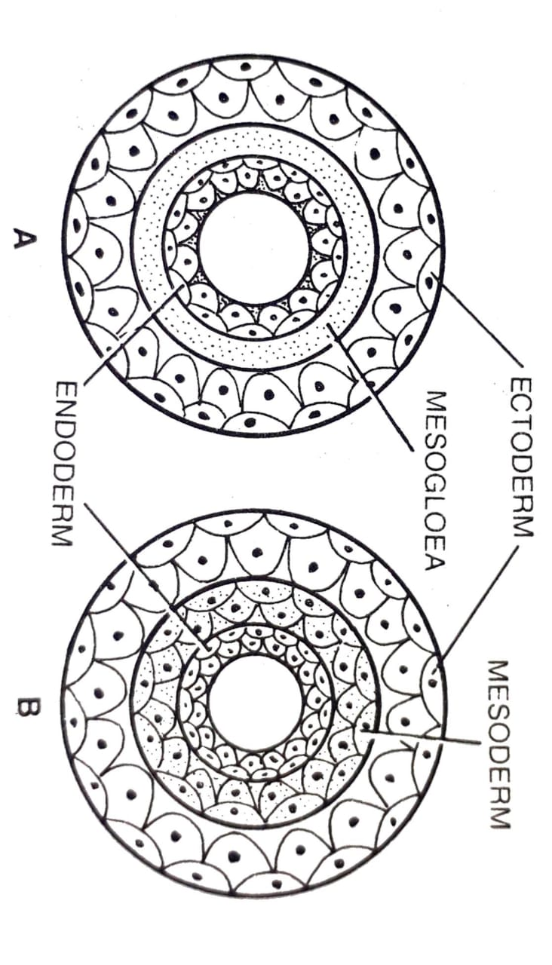

|  |  |
| --- | --- |
| a) Diploblastic , Triploblastic | b) Triploblastic , Diploblastic |
| c) Diploblastic , Diploblastic | d) Triploblastic , Triploblastic |

1. Match column I and column II

|  |  |
| --- | --- |
| Column I | Column II |
| A. Organ level | I. Pheretima |
| B. Cellular aggregate level | II. Fasiola |
| C. Tissue level | III. Spongilla |
| D. Organ system level | IV. Obelia |

|  |  |
| --- | --- |
| a) A – IV ; B – I ; C – II ; D – III | b) A – IV ; B – I ; C – III ; D – II |
| c) A – II ; B – III ; C – IV ; D – I | d) A – I ; B – IV ; C – III ; D – I |

1. Match column I and column II

|  |  |
| --- | --- |
| Column I | Column II |
| A. Porifera | I. Canal system |
| B. Aschelminthes | II. Water vascular system |
| C. Annelida | III. Muscular pharynx |
| D. Arthropoda  E. Echinodermata | IV. Joint appendages  V. Metameres |

|  |  |
| --- | --- |
| a) A – II ; B – III ; C – V ; D – IV ; E – I | b) A – II ; B – V ; C – III ; D – IV ; E – I |
| c) A – I ; B – III ; C – V ; D – IV ; E – II | d) A – I ; B – V ; C – III ; D – IV ; E – II |

1. Match column I and column II

|  |  |
| --- | --- |
| Column I | Column II |
| A. Metamerism | I. Coelenterate |
| B. Canal system | II. Ctenophora |
| C. Comb plates | III. Annelida |
| D. Cnidoblasts | IV. Porifera |

|  |  |
| --- | --- |
| a) A – IV ; B – I ; C – II ; D – III | b) A – IV ; B – III ; C – I ; D – II |
| c) A – III ; B – IV ; C – I ; D – II | d) A – III ; B – IV ; C – II ; D – I |

**[Class =11th]**

**Answers**

|  |
| --- |
| 1. c |
| 1. c |
| 1. c |
| 1. c |
| 1. b |
| 1. c |
| 1. d |
| 1. d |
| 1. d |
| 1. d |
| 1. c |
| 1. d |
| 1. d |
| 1. b |
| 1. d |
| 1. d |
| 1. d |
| 1. b |
| 1. c |
| 1. d |
| 1. d |
| 1. c |
| 1. d |
| 1. d |
| 1. c |
| 1. d |
| 1. a |
| 1. b |
| 1. b |
| 1. a |

**Topic: Animal Kingdom (Non-Chordates)**

|  |
| --- |
| 1. b |
| 1. c |
| 1. d |
| 1. c |
| 1. b |
| 1. d |
| 1. c |
| 1. d |
| 1. b |
| 1. c |
| 1. d |
| 1. b |
| 1. d |
| 1. c |
| 1. d |
| 1. c |
| 1. d |
| 1. a |
| 1. a |
| 1. c |
| 1. a |
| 1. c |
| 1. c |
| 1. b |
| 1. d |
| 1. c |
| 1. b |
| 1. a |
| 1. b |
| 1. a |

|  |
| --- |
| 1. b |
| 1. d |
| 1. c |
| 1. d |
| 1. b |
| 1. c |
| 1. a |
| 1. d |
| 1. b |
| 1. a |
| 1. a |
| 1. d |
| 1. d |
| 1. d |
| 1. d |
| 1. a |
| 1. b |
| 1. b |
| 1. a |
| 1. b |
| 1. b |
| 1. a |
| 1. a |
| 1. a |
| 1. b |
| 1. c |
| 1. a |
| 1. c |
| 1. c |
| 1. d |